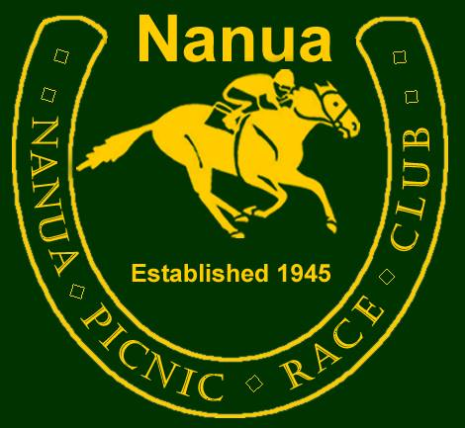
Bar Policy Approval Date: 2016

This establishment has a policy to serve patrons in a responsible, friendly and professional manner. Our staff is on hand to assist patrons in their decision to drink in moderation and where appropriate avoid the dilemmas of combining drinking with driving. Our bar staff will not serve any person under the age of 18 years of age nor any person to intoxication.

TED BRIGHT BAR RULES

- Abusive language will NOT be tolerated.
- Swearing at our bar staff will NOT be tolerated.
- Intoxicated persons will be refused service of alcohol & suggest patron have some water or non alcoholic drink.
- Fighting will NOT be tolerated.
- Bad behaviour will NOT be tolerated.
- Underage drinking will NOT be tolerated.

PROOF OF AGE MUST BE SHOWN.

The volunteers and staff will be sober, polite & courteous & treat patrons with respect at all times.

NANUA is a not for profit club that donates all our bar profits to local charities, when having a drink YOU are helping someone less fortunate than you.

Chairman of Nanua P R C
Des Kennedy 2015

