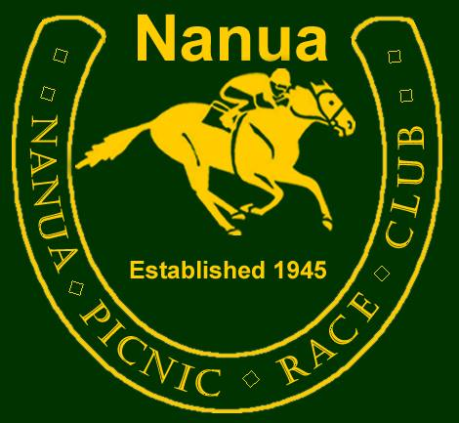
Safety Policy Approval: 25 June 2011

Policy
The safety of all persons either active in conducting an event, competing or spectating is of the utmost importance. The Nanua Picnic Race & Quarter Horse Club Incorporated will make resources available and minimise risks to ensure the event is run safely.

Safety Responsibilities

Promoting and maintaining safety is primarily the responsibility of the Committee.

All committee members are required to follow the Safety Policy and procedures to ensure their health and safety and the health and safety of others.

Competitors and members of the general public are reminded of their common law duty not to cause harm to others either wilfully or negligently.
- Competitors will be reminded of their safety responsibilities when nominating.

All patrons will be informed when first entering the grounds of the Safety Policy and informed of their obligations. Public announcements throughout the day will remind visitors of their safety obligations.

Patrons are asked to bring to the attention of the committee any concerns relating to safety or any potential safety issues.
Implementing the policy
The Club will implement the Safety Policy by adopting The Australian Quarter Horse Association Risk Audit for Event Management:
- Develop and implement a Hazard and Risk Management Plan.
- Promote, maintain and improve safety procedures.
- Follow the 5-step risk management approach to hazards in the workplace
- See the hazard (Identify)
- Assess the risk
- Fix it (Control)
- Evaluate the Control (Review)
- Record it
In order to implement the general provisions of this policy, a program of activities and procedures will be set up, continually updated, and effectively carried out:
- Emergency procedures
- Event site inspections and evaluations
- Reporting and recording of incidents, accidents, injuries and illnesses
- Development of an ongoing consultation plan.

This Policy will come in to effect from 1st July 2011 and will be reviewed subject to discussion and agreement of the committee.

