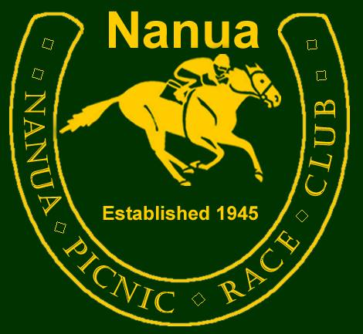
Social Media Policy Approval: 9 July 2018

All members have the right to be part of the Nanua Equestrian Club Group and Nanua Picnic Race and Quarter Horse Club page

The club, committee and all members need to ensure...
- That appropriate language and behaviour is used at all times.
- That all club polices and procedures have been adhered to.

Appropriate Language and behavior
- Positive comments or suggestions that can be entertaining without being offensive.
- Supportive discussions about horse related issues or club issues.
- Don't be offended if someone disagrees, everyone has a right to their opinion
- Try suggesting what you would do instead of saying something negative
- Don't make a big deal over things - if you are annoyed then contact the club Secretary or Patron and discuss the issue. Figure out a course of action with them.

Inappropriate Language and Behavior
- Swearing even with letters deleted or replaced.
- Arguing in posts, if someone disagrees don't keep commenting as it just continues a no win argument.
- Abusive or derogatory comments.

Suggestions for better communication
- Think first, talk to others privately then act.
- If you have a problem with someone, talk about it with the committee first before putting a message on FaceBook or sending an email. Sometimes an outside perspective can calm us down and make us realise our actions will achieve no good outcome.
- Private messages or emails are better than putting up a group post when you are upset as others who will be drawn into your private dispute.
- We don't have to be best friends but we do have to be civil and work together in the interest of the Club.

Implementing the policy
The club will appoint FaceBook Officers to ensure the policy and procedures of the club are met.

The Facebook Officer will monitor all communications on the page and group.
- The Facebook Officer will discuss any major actions they intend to take with the Secretary or Patron, or at least 2 other ordinary committee members.
- They will delete inappropriate posts or comments without drawing attention to it. They will communicate this decision to the Secretary or Patron.
- When inappropriate language is used quietly delete the comment. Do not draw attention to it.

The club reserves the right to cancel a membership if the clubs policies are not followed. This decision will not be taken lightly and will be discussed with the executive committee.

ABN: 93 778 453 913 www.nanua.net secretary@nanua.net

