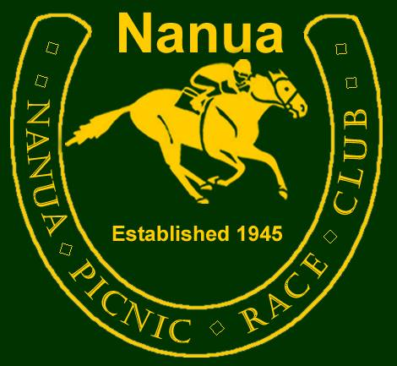
Volunteer Drinks Policy Approval: 2016

The club would like to remind all volunteers that we are a NON-PROFIT organisation please consume all drinks in moderation.

Volunteers are responsible for their own actions and safety. They need to ensure they follow all rules and laws. All volunteers maybe refused any drink should the club deem fit.

The club requests all volunteers to drink in moderation as you are a representation of the club when working in your official capacity.

Working Bees
Volunteers will be supplied with soft drinks and water throughout the event. At the end of the day a carton of beer will be provided to be shared among volunteers who attended for the day with a two beer limit.

Catering and other event days
Volunteers will be supplied with soft drinks and water for the duration of the event.

Race Weekend
Volunteers will be supply water and soft drinks to all assisting throughout the day.

All alcohol will need to be purchased.

At the end of the weekend the Bar Licensee and the Club President may choose to hand out open or loose products should any be available to volunteers who go above and beyond the call of duty to support the club. This is at their discretion.

This guide is flexible and will be adjusted as necessary as the committee see necessary.

ABN: 93 778 453 913 www.nanua.net secretary@nanua.net

