Monday, 1 July 2018

Dear Sponsor,
I am writing to ask if you would sponsor the Nanua Picnic Races & Gymkhana held on the weekend of Saturday the 20th October 2018 at the Kimberley Station Racecourse, south of Broken Hill.
This year we are raising awareness of bullying and mental health in our community with our ANYTHING BLUE SATURDAY. Inspired by Dolly’s Dream about being kind and speaking up even if your voice shakes we ask all patrons to wear something blue and buy ticket in our raffle or make a donation. If you haven’t read about Dolly’s story then please head to their page www.facebook.com/dollysdreamaustralia/
The weekend provides entertainment for the whole family, kicking off Friday night with our Mexican Madness theme night and karaoke. On Saturday we have the events for people and horses like tug-a-war, barrel races, foot races and ending the day with a live band in the hall.
Over the last 18 years we have donated over $110,000 to charity, an amazing effort thanks to the support of our sponsors and by the 300 to 400 people who annually attended throughout all kinds of weather.
We could not run without the support of sponsors assisting us with the cost of hosting the event. Should you be willing to assist our organisation, we would greatly appreciate your generous hospitality and enclose herewith is our sponsorship form for your assistance.
We wish to thank you for taking the time to read our letter requesting sponsorship and we hope to see you at our picnic day this year.
Yours Faithfully,

Suzanne Withers
Treasurer

President Des Kennedy Secretary Lee-Anne Bright Treasurer Suzanne Withers
Vice President - George Harrison Assistant Secretary - Marika Harrison Public Office: Chris Bright
Committee: Richie Withers, Jacintha Gillett, Jan Bright, Nick Withers, Bianca Garden, Jo Gall, David Shrimpton

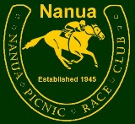 | 2018 Sponsors Form
Please return this form to ensure that our Club has the correct information in our database and to help us promote our sponsors please fill in this form. Tax invoices and programs will be posted in due course.
Sponsorship Value |  | $ |  |  | Previous Donation
 |  |  |  |  | $
Description
Sponsor Name For Programme
Contact Person
Email Address
Website
Phone or Mobile
Postal Address

Street Address
Please return to ....
 |  |  | Postal Address: | Nanua Picnic Race & Quarter Horse Club Inc.  PO Box 195,  Broken Hill NSW 2880
 |  |  | Email Address: | sponsorship@nanua.net
All enquiries to our Treasurer, Suzanne Withers, on 08 80911506 or treasurer@nanua.net
or our Sponsorship Coordinator, Tracey Bright sponsorship@nanua.net

 | Tax Invoice | ABN 93 778 453 913  Nanua Picnic Race Club  PO BOX 195  Broken Hill NSW 2880
THANK YOU FOR SUPPORTING the Nanua Picnic Races & Gymkhana
Date: 1 July 2018

Reference Number:

TO
DESCRIPTION |  |  | TOTAL
Advertising sponsorship at the Nanua Picnic Races & Gymkhana  on the weekend of the 20th of October 2018 |  |  | $
PAYMENT
Bank: ANZ

Account Name: Nanua Picnic Race & Quarter Horse Club Inc
BSB: 012551
Ac No: 262147774

Description: Sponsors Name
All enquiries to our Treasurer, Suzanne Withers, on 08 80911506 or treasurer@nanua.net
or our Sponsorship Coordinator, Tracey Bright sponsorship@nanua.net

Thank you

Sponsor Name

for SPONSORSHIP of the

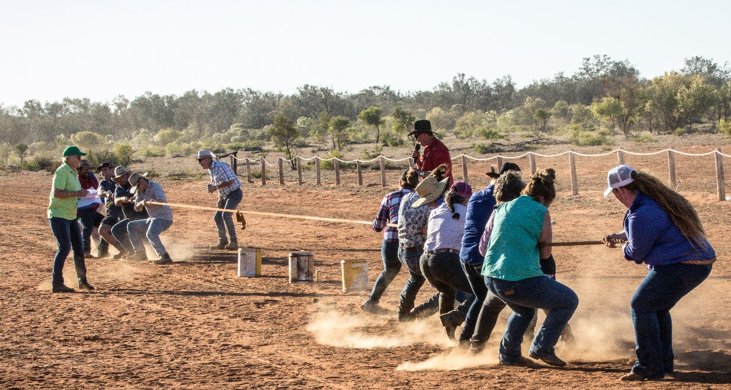

NANUA PICNIC RACES & GYMKHANA 2018

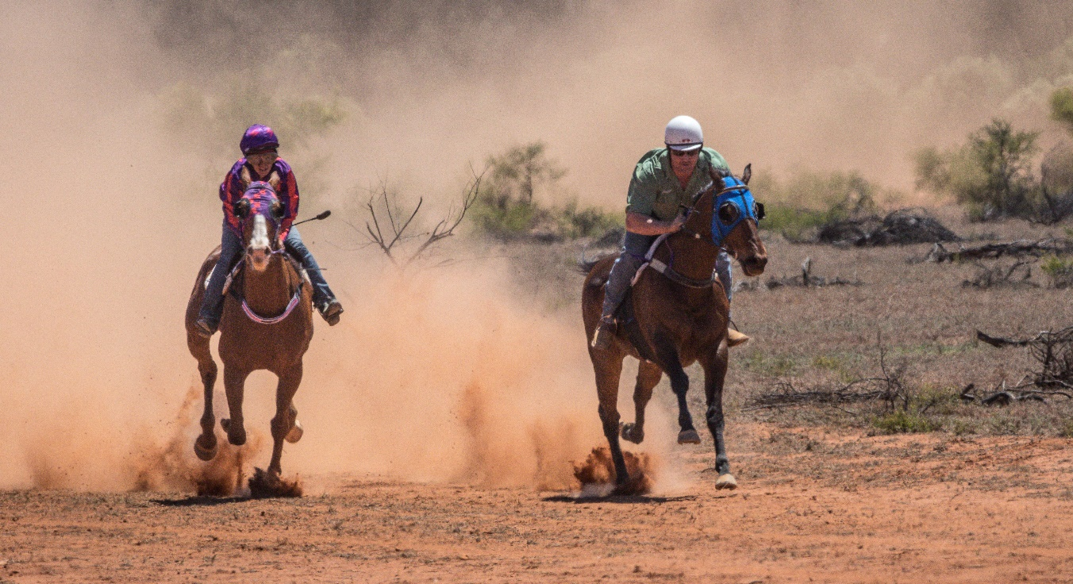
Fundraising, Advertising Sponsorship and Donation Policy
Nanua Picnic Race Club Inc. relies on the support of our sponsors and donations to undertake activities and give charities in our community.

Definitions
- “Donations” are goods, services or money given with no return expected.
- “Sponsorship” is the provision of cash or services by the sponsor for an agreed set of benefits from the club.
- “Endorsement” is the public support of our organisation, products or projects.
- “Sponsor” is defined as a corporation, business or individual that provides support for the Club.
- “The Club” is the Nanua Picnic Race Club Inc.
Nanua Picnic Race Club Inc. will use fundraising to actively seek sponsorship and donations to support activities of the club.
- Major Sponsors will be acknowledged by written agreements between the Club and the prospective partner.
- All sponsorships will be conducted in an open and transparent manner and the Club will formally thank all sponsors for their involvement via written communication.
- Expenditure of funds raised through sponsorship shall be agreed upon by the Club Committee.
- Sponsorship of any particular project or event sanctioned by the Club will not entitle any sponsor to influence any decision.
- The Club will not enter into any sponsorship where association with the prospective partner would jeopardise the financial, legal or moral integrity of the Club or adversely impact upon the Club standing and reputation within the community.
- The Club may endorse products, organisations or projects that aid the cause, policy or interests of the Club and the Club may receive remuneration for such endorsements.

Types of Advertising Sponsorship and Donations
PLATINUM
- $1000 plus
- Name and logo on advertising ticket, flyers, program, website and facebook page
- 6 Complimentary Tickets, 6 Stubbyholders, 6 Stickers
- Banners and fence advertising signs welcome
- Deals can be negotiated for meal and drinks to be included.

GOLD
- $500 plus
- Name on advertising ticket, flyers, program, website and facebook page. Logo included as space allows.
- 3 Complimentary Tickets, 1 stubbyholder, 1 Sticker
- Banners and fence advertising signs welcome

SILVER
- $200 to $499
- Name on event on program and advertised on website and facebook page.
- 2 Complimentary Tickets

BRONZE
- Under $200
- Name listed on program and on facebook.
- 1 Complimentary Ticket

PRIVATE - Private donations are from people who quietly want to contribute without name being listed anywhere.

