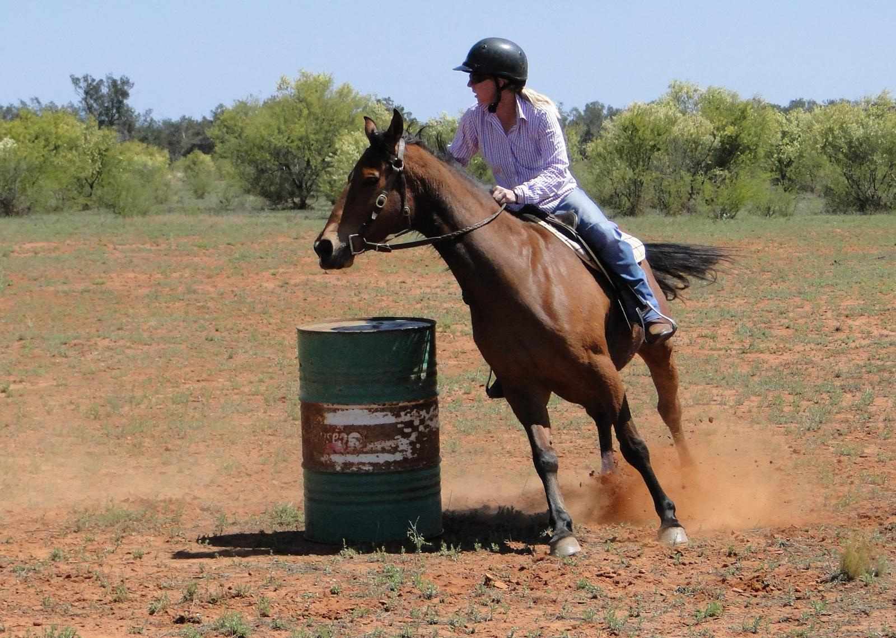
NANUA
Picnic Races & Gymkhana
18th & 19th October 2013
www.nanua.net
“I’ve been there, why haven’t you”

Thanks to all past sponsors including the following 2012 Gold Sponsors Elders Insurance, BSL, 5RM, 2BH, M’Liss McBride’s Family
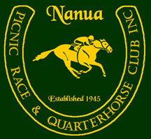


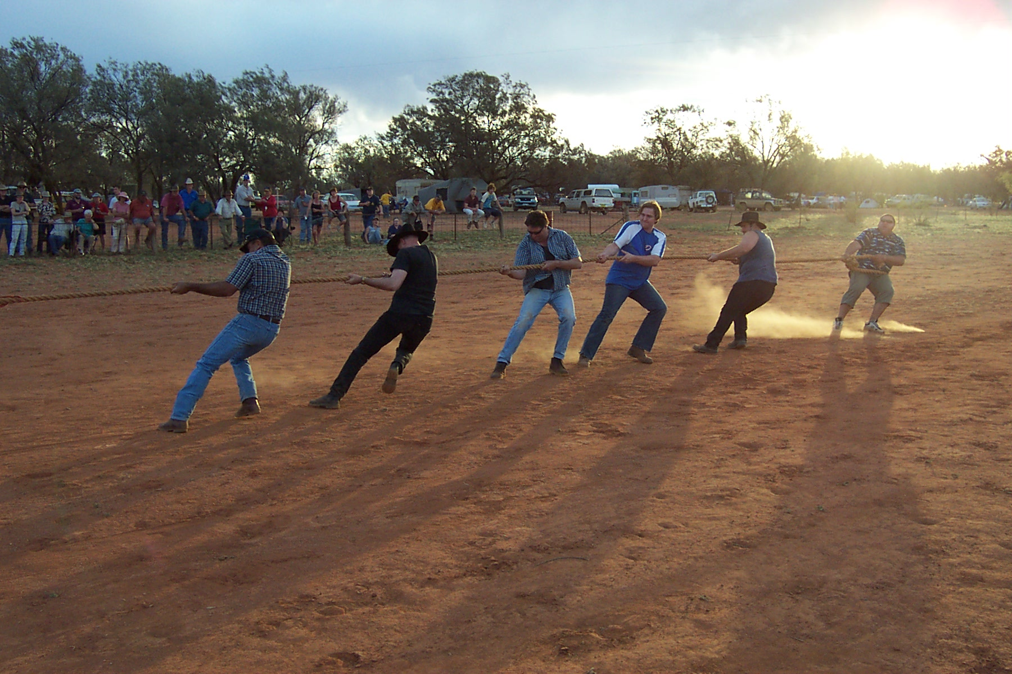


Friday Night

“COWBOYS & INDIANS”

Costume Prizes Awarded
Bar Opens at 6.30pm
GEORGIE’S MUSICK MAGICK Karaoke
Saturday

Events start at 9.30am
Office Opens 8am
Bar Opens at 10.30am
Toy Library for the kids
LIVE BAND

Admission: $12
includes entertainment, gate prize for adults & kids, shower facilities & power
FULL FOOD CATERING All Weekend with Legacy

KIMBERLEY RACECOURSE

MUDMAP on website with directions - 140 km south of Broken Hill, - 240 km north of Renmark, - 250 km north of Mildura,- 260 km East of Burra - Chris Bright 0880911624 - Suzanne Withers 0880911506

