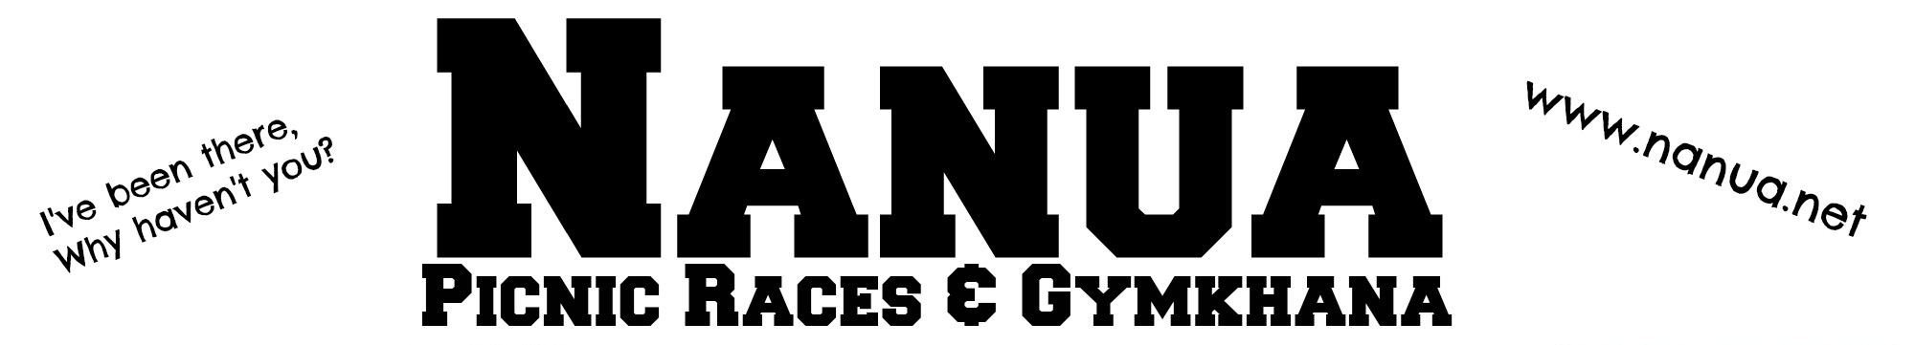

the weekend of the
18th October 2014
Kimberley Station Racecourse – in the middle of everywhere
140km south of Broken Hill, NSW – 200km north of Renmark, SA – 250km north of Mildura, VIC - 260km East of Burra, SA - MUDMAP on the website
  secretary@nanua.net  Admission $12  Includes band, gate prize, shower facilities and power.  Full Food Catering  All Weekend with Legacy  No glass allowed  on the grounds  ST JOHN’s RAFFLE  Tickets $1 | 1) Schinella's Food & Liquor RIDER BRIEFING | MAJOR SPONSORS  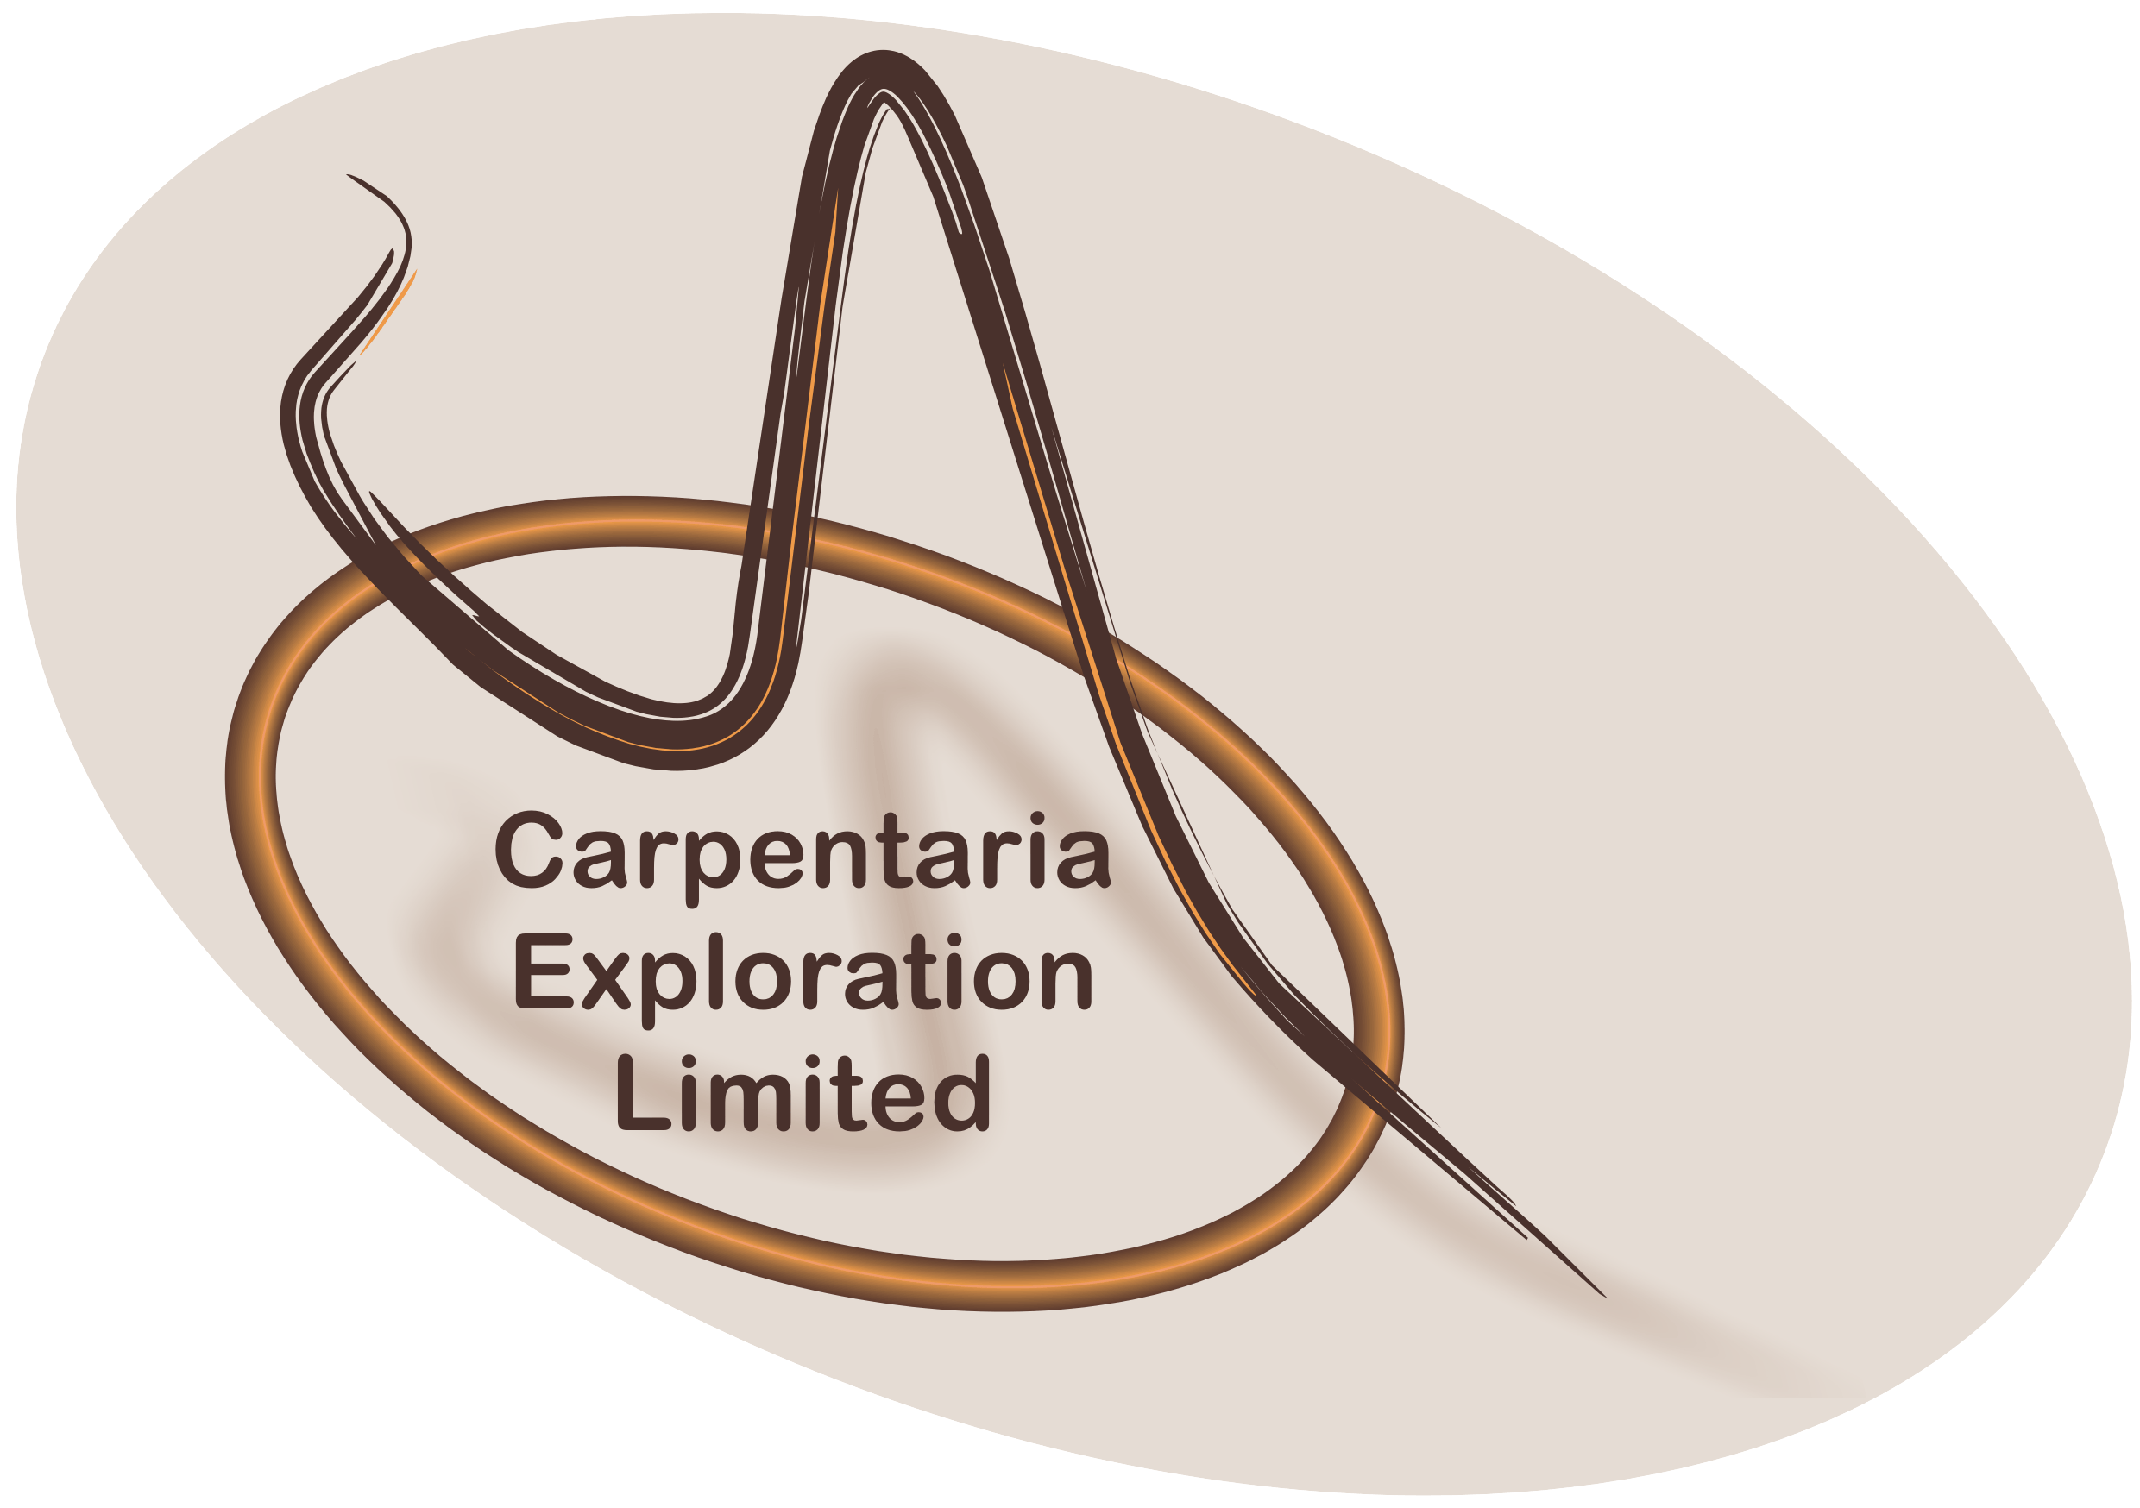
 | 2) Broken Hill Exhaust & Engineering UNDER 10 LED BENDING RACE,
 | 3) Garry Remmert 10 TO 13 YEARS BENDING RACE,
 | 4) B R & C 14 TO 17 YEARS BENDING RACE
 | 5) BSL - Basin Sands Logistics OPEN BENDING RACE
 | 6) Aussam Geotechnical Services OPEN SPRINT, 400m ***1st: $300 2nd: $200 3rd: $100
 | 7) JUNIOR FLAG RACE | GOLD SPONSORS    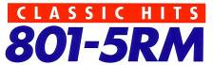      Demo Club  Broken Hill
 | 8) Mulga Hill Tavern OPEN FLAG RACE
 | 9) UNDER 10 LED BARREL RACE,
 | 10) Elders (Broken Hill) 10 TO 13 YEARS BARREL RACE,
 | 11) Netley Proprietors 14 TO 17 YEARS BARREL RACE
 | 12) DEMO CLUB MEN’S OPEN BARREL RACE ***1st: $400 2nd:$100 3rd: $50
 | 13) Carpentaria Exploration LADIES OPEN BARREL RACE ***1st: $400 2nd:$100 3rd: $50
14) JC SMITH FAMILY MEMORIAL CUP 600 metres ***1st: $500 - 2nd: $300 - 3rd: $200
~ Gettin There Dingo Services Presentation Rug
~ Ron Harvy Award for the winning JOCKEY
~ Grant Brine Mobile Workshop Cup for winning horse
FRIDAY  17th October 2014  SUPERHEROES  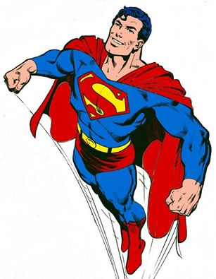  Friday Night Theme  Dress up and win a prize  Georgie’s Musik Magick  Bar Open  7pm to 10.30pm | 15) Rosella Distributors CHILDREN’S FOOT RACES and NOVELTIES
 | 16) Western Auto Electrical & Sprint Auto Parts MEN’S FOOT RACE ***Trophy
 | 17) Dr Greg Cocks @The Dental Centre UNDER 10 LED MONTE CARLO
 | 18) DJR Distributors 10 TO 13 YEARS MONTE CARLO, | THANK YOU to MAWSON PLANT & QUARRY and BROMSON’S ENERGY  for their support  Proceeds in aid of Legacy, St Johns, OMRU Toy Library, and other community charities  No dogs allowed.  Gate Fines Apply  Club Membership $5 is required to enter any event and for all competitors. .  Rules and Conditions of events available on website. Cash prize for horse events, unless otherwise stated, 1st $50, 2nd $30, 3rd $20  Chris Bright  Kimberley Station 0880911624  Suzanne Withers 0880911506
 | 19) Bindara on the Darling UNDER 14 YEARS LED & RIDDEN LUCKY ENVELOPE RACE
 | 20) George Goodie Memorial BRACELET, 400m ***1st: $300 2nd: $200 3rd: $100
 | 21) Landmark (Broken Hill) 14 TO 17 YEARS THREAD THE NEEDLE
 | 22) Spot On Outdoors OPEN THREAD THE NEEDLE
 | 23) Spicer's Office Choice OPEN BALLOON RACE
 | 24) Macarthurs MSVDH UNDER 10 LED MUSICAL CHAIRS
 | 25) Browzers Bookshop 10 TO 13 YEARS MUSICAL CHAIRS
 | 26) Formula Motor Parts 14 TO 17 YEARS MUSICAL CHAIRS
 | 27) Dann's of Broken Hill OPEN MUSICAL CHAIRS
 | 28) JUNIOR LEMON RACE
SATURDAY  18th October 2014  Office Open: 8.30am  Bar Open: 10.30am  Toy Library from approximately 10.30am  LIVE BAND at night  COUNTRY SPIRIT | 29) HACK RACE, 200 metres
 | 30) 801 - 5RM and Magic 93.1 YABBY RACE
 | 31) Harcourt Station UNDER 14 YEARS WHIPCRACKING
 | 32) UNDER 18 YEARS WHIPCRACKING
 | 33) Outback Whips & Leather OPEN WHIPCRACKING
 | 34) Outback Pharmacies WOMEN’S THROW THE ROLLING PIN *Value $100
 | 35) Broken Hill GP Super Clinic WOMEN’S DRIVE THE NAIL *Value $100
 | 36) Alfresco THRONE RACE
 | 37) Elder Insurance TUG ‘O’ WAR Men & Mixed Teams 6, Women 8 max $500
THANKYOU FOR THE FOLLOWING:
ANZ members wristbands Olga Kennedy Kids Gate Prize
IOR Petroleum Gate Prize Sturt Club Red Lantern Award
BILANDES Sportsmanship and Jockey Awards

Program Version 1

AGE GROUPS FOR COMPETITORS
- Age groups are as follows;
  - Under 10 Led
  - 10 to 13 year olds
  - 14 to 17 year olds
  - OPEN

  - JUNIOR events are for competitors under 18 years

AGE Competitor must stay in the same age groupings for the entire day.
- Competitors in Under 10 LED, 10 to 13 year olds and 14 to 17 year olds may ride in one age group above with parental permission and by approval of the Secretary but MUST stay in that age group for the remainder of the competition.

EQUIPMENT
Approved helmets to be worn at all times when on the horse at the grounds.
All riders must where sleeved shirts, no singlets.

NOMINATIONS

Nominations for Ladies and Men’s Open Barrel Race is $5.
Nominations for all other events are free.

GENERAL EVENT RULES
- All participants must be current members of the club.
- No rider shall be permitted to partake of intoxicating drink before their last event.
- Judges decision is final.
- All participants compete at their own risk.
- Horses shall be nominated and ridden in all events of the Club by members only with the approval of the committee.
- All riders competing at the Club’s event must be non-professional or by special permission of the committee.
- The Committee reserves the right to change or delete any part of the program or allotted prizes.
- The Committee has the right to remove or order from the grounds any person or horse acting in a dangerous or uncontrollable manner as to cause embarrassment or injury to others.
- Competitor’s/participants at any event run by Nanua Picnic Race & Quarter Horse Club Incorporated have a responsibility to ensure the welfare of their horses and at all times to treat their horses humanely and with dignity, respect and compassion.
- Competitors/participants are to conduct themselves in a professional manner and act with integrity in all dealings with the Affiliate and other competitors. To uphold the rules and regulations of the Nanua Picnic Race & Quarter Horse Club Incorporated and the AQHA at all times.
- Competitors/participants are to demonstrate good sportsmanship at all times, showing respect for your fellow competitors and officials, following the rules and to treat people the way you yourself wish to be treated.
  - The starting of events must be left to the discretion of the judge or Official Starter, recalling the field if he/she considers it necessary
  - A competitor who causes interference during an event or does not make sufficient effort to stand his/her horse at the start line will be disqualified and, if disqualified, shall not be permitted to start in a re-run.

RACE RULES
Minimum weight for all flat races 63.5kg., except Jumbo, live weight 73 kg., race weight minimum 83kg or as decided by the Committee.
All riders in flat races to be 16 years and over.
Competitors in flat races to wear colours if possible.
HACK RACE: Riders must be 16 years and over, stock/G.P Saddles. At stewards discretion complete any two novelty events before start of Hack Race.

NOVELTY RULES
Novelty events run under Committee Rules based on Sporting Horse Australia Rules. Available at Secretary's Office or online.

